ASSIGNMENT-9.1
2303A52364
BATCH-32

Consider the following Python function:
def find_max(numbers):
return max(numbers)
Task:
• Write documentation for the function in all three formats:
(a) Docstring
(b) Inline comments
(c) Google-style documentation
• Critically compare the three approaches. Discuss the
advantages, disadvantages, and suitable use cases of each
style.
• Recommend which documentation style is most effective
for a mathematical utilities library and justify your answer
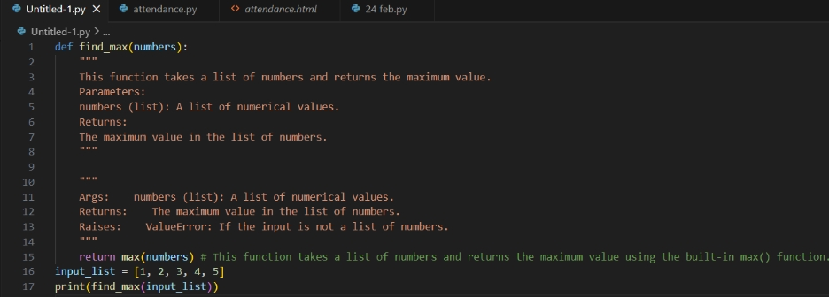

Inline Comments
Advantages:
- Simple and quick
- Useful for explaining specific lines.
Disadvantages:
- No structure.
- Cannot clearly document parameters or exceptions.
- Not suitable for reusable libraries.
- Best Use Case:
Small scripts or explaining complex logic inside a function.

Basic Docstring
Advantages:
- Clear overview of function purpose.
- Easy to write and understand.
Disadvantages:
- No strict structure.
- Exceptions are often unclear.
Best Use Case:
Small projects or beginner-level code.

Google-Style Docstring
Advantages:
- Structured and consistent.
- Clearly documents arguments, return types, and exceptions.
- Suitable for auto-generated documentation tools.
Disadvantages:
- Slightly more verbose.
Best Use Case:
Professional projects, libraries, APIs, and large systems.

Use Google-style documentation.
Reason: A mathematical utilities library will be reused by many developers. Functions must clearly define input types, return types, and possible errors. Structured documentation prevents misuse and improves maintainability.
Problem 2: Consider the following Python function:
def login(user, password, credentials):
return credentials.get(user) == password
Task:
1. Write documentation in all three formats.
2. Critically compare the approaches.
3. Recommend which style would be most helpful for new
developers onboarding a project, and justify your choice.
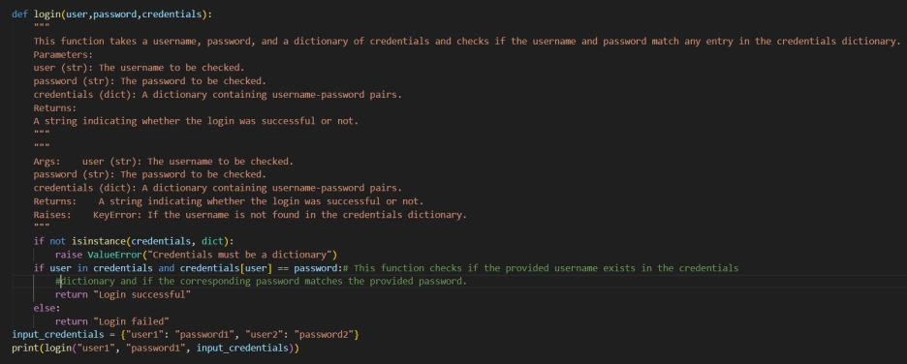
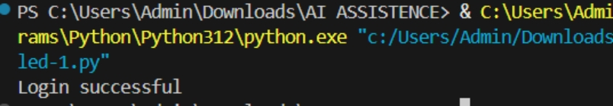

Inline Comments
Advantages:
- Very simple.
- Useful for explaining a single line of logic.
Disadvantages:
- No structure.
- Does not clearly define inputs or return type.
- Not helpful for understanding function contract.
Use Case:
Small scripts or quick internal code.

Basic Docstring
Advantages:
- Gives a clear description of purpose.
- Easy to write and read.
Disadvantages:
- No strict structure.
- Exceptions and return types may not be clearly defined.
Use Case:
Small or medium projects.

Google Style
Advantages:
- Clearly separates arguments, returns, and errors.
- Easy to scan and consistent.
- Good for team projects.
Disadvantages:
- Slightly longer to write.
Use Case:
Professional systems, APIs, shared libraries.
Use Google-style documentation.
Reason: New developers need clarity about inputs, outputs, and possible errors. Structured documentation reduces confusion and speeds up onboarding.

Problem 3: Calculator (Automatic Documentation Generation)
Task: Design a Python module named calculator.py and
demonstrate automatic documentation generation.
Instructions:
1. Create a Python module calculator.py that includes the
following functions, each written with appropriate docstrings:
o add(a, b) – returns the sum of two numbers
o subtract(a, b) – returns the difference of two numbers
o multiply(a, b) – returns the product of two numbers
o divide(a, b) – returns the quotient of two numbers
2. Display the module documentation in the terminal using
Python’s documentation tools.
3. Generate and export the module documentation in HTML
format using the pydoc utility, and open the generated HTML
file in a web browser to verify the output.

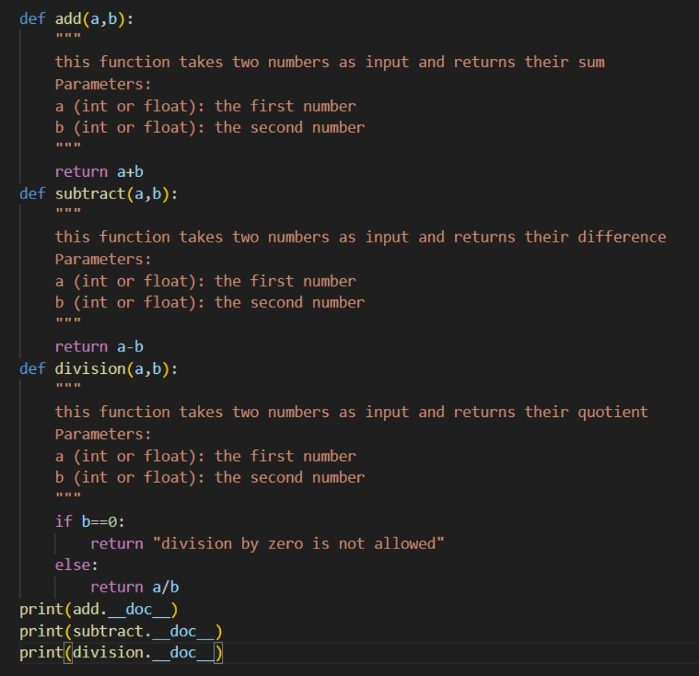

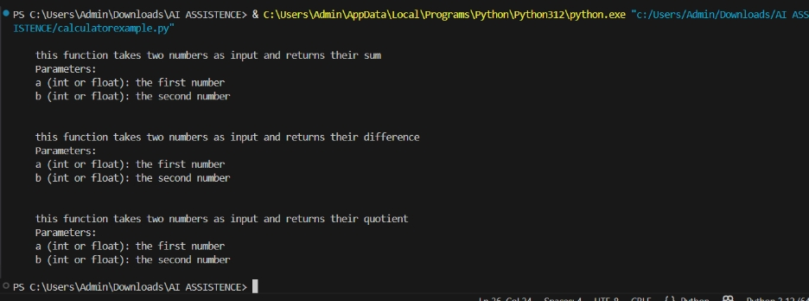

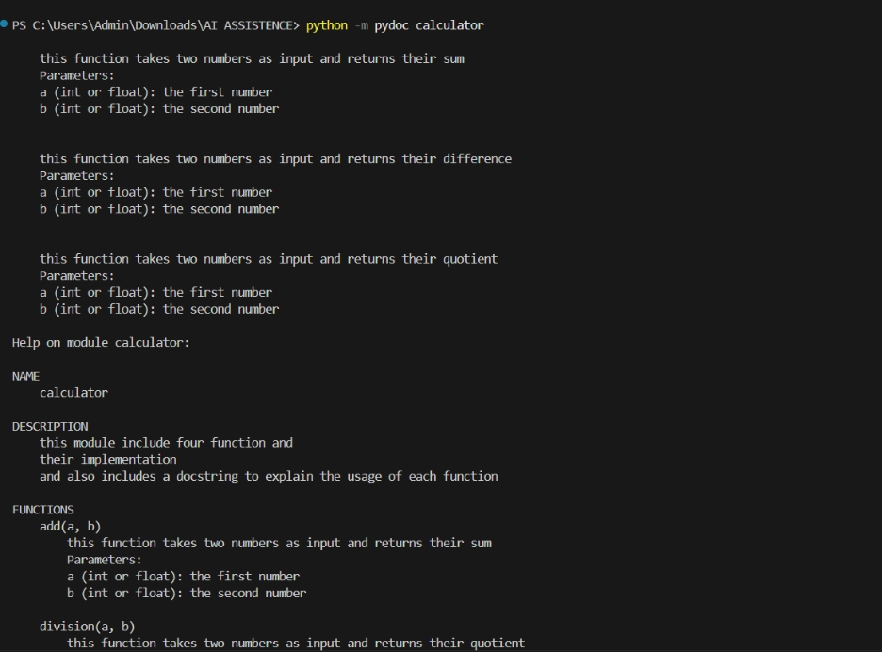
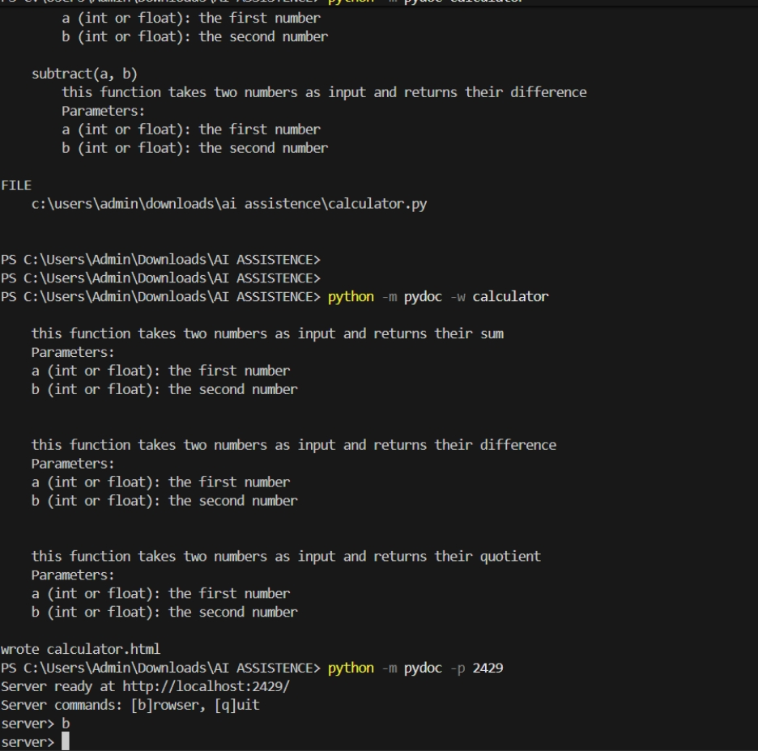
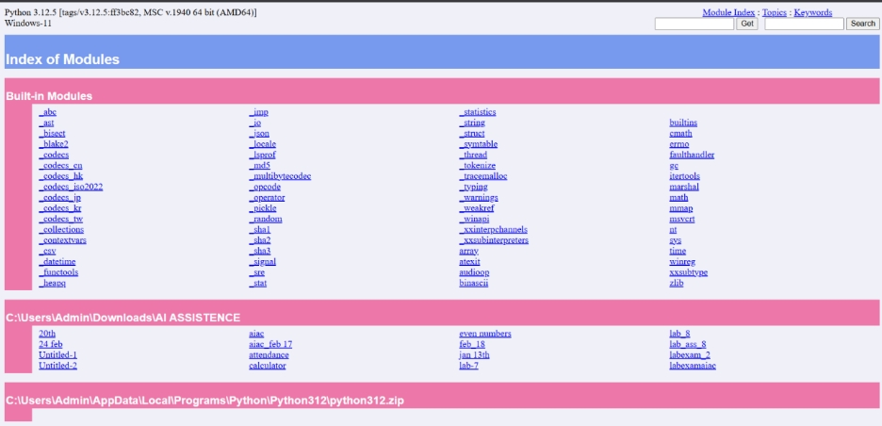
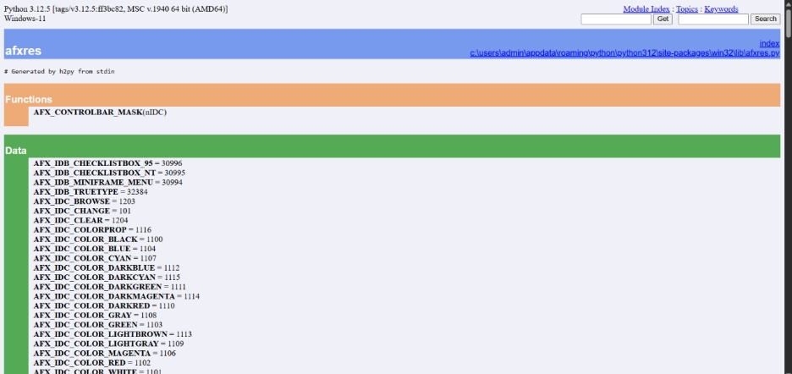
Problem 4: Conversion Utilities Module
Task:
1. Write a module named conversion.py with functions:
o decimal_to_binary(n)
o binary_to_decimal(b)
o decimal_to_hexadecimal(n)
2. Use Copilot for auto-generating docstrings.
3. Generate documentation in the terminal.
4. Export the documentation in HTML format and open it in a
browser.
